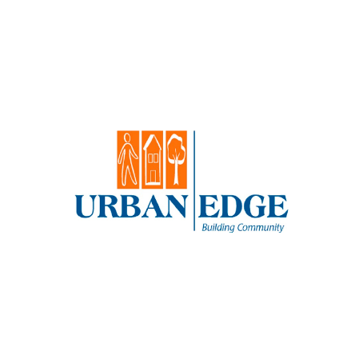

Urban Edge is excited to announce that we are hiring a Director of Real Estate. We are

looking for an individual with deep real estate development knowledge, who is mission driven

and entrepreneurial.

We are one of the largest not-for-profit community development corporations in Massachusetts,

located where Boston’s Latin Quarter meets its historic African American neighborhood, at

the crossroads of Jamaica Plain and Roxbury, in Jackson Square.

Urban Edge has a 2023 annual operating budget of over $6.0 million, and we employ a staff of

over 30. We have developed over 1,500 units of affordable housing and maintain a portfolio of

over 1,400 units. Residents of our housing and our community are diverse and multilingual. In

2023, we anticipate serving more than 2,500 families.

Our ideal candidate will enthusiastically seek new development opportunities to

meet Urban Edge&#39;s standards for innovation and excellence. They will be capable of managing

multiple, complex real estate transactions. They will facilitate a team approach and

have experience working in a diverse multi-cultural, mixed income community.

Our salary range for this position is $150,000 to $180,000 depending on qualifications and

experience. We offer an excellent benefit package.

**LINK:**

https://annlsilverman.com/urban-edge-director-of-real-estate/ for a full position description.